**Introduction to the** **Benchmark Challenge on**

**Intelligent Chassis Control**

**Abstract**

The intelligent chassis has garnered growing attention in both academia and industry, thanks to its advantages in wire-control, electrification, modularization and informatization. Consequently, it becomes the optimal platform for the development of autonomous vehicles. The performance improvement of intelligent chassis under extreme conditions is one of the characteristics highly regarded by researchers. This improvement is achieved through a well-designed coordination control strategy that effectively manages multiple mounted actuators. In order to promote development of related research, the Benchmark Challenge of CVCI2024 provides a technology exchange and study platform composed of a high-fidelity vehicle dynamic model with active rear steering (ARS) and four distributed in-wheel motors mounted, abundant testing scenarios in purely simulation environment and driving simulator for driver in loop testing. An evaluation system derived from typical domestic and international standards will be applied for performance comparison of coordinate control strategies from various perspectives.

1. **Introduction**

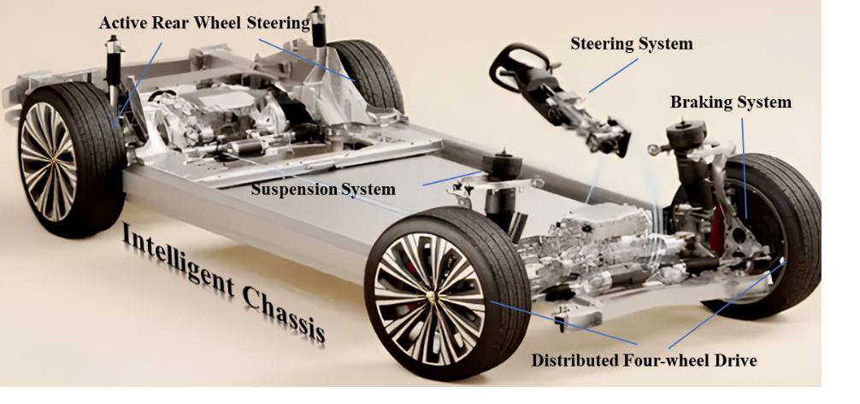

Figure 1: Intelligent Chassis

In the era of assisted and autonomous driving features, the newly emerged intelligent chassis is playing an increasingly pivotal role in enhancing vehicle performance, attributed to its characteristics of wired control, electrification, modularity, and informatization. As a result, both the industry and academia have expressed considerable interest in advancing research in this field.

A distinct feature of intelligent chassis is its multiple controlled-by-wire actuators. The feature seeks to enhance the overall performance of the vehicle's dynamics, particularly in extreme conditions like high-speed obstacle avoidance or emergency braking while cornering, during which the coordinated action of chassis actuators extends the stability boundary of the vehicle, as illustrated in Figure 2. While the coordination of different actuators is a difficult task in intelligent chassis design. Different chassis actuators have unique influence on vehicle dynamic while there are overlapping range of effectiveness among them. Besides there is coupling effect of “lateral-longitudinal-vertical” in vehicle dynamic control, which means a coordination strategy taking coupling mechanism into account is crucial to play full performance of the intelligent chassis in extreme condition. For example, the four-wheel steering (4WS) system mainly influences the lateral dynamic and is more efficient in tire linear region, while TVC and ESC can work in tire slip region and have effect in both longitudinal and lateral dynamics. Furthermore, TVC causes less reduction in longitudinal speed than ESC, a well-designed controller should delay the action of ESC on the premise of ensuring safety.

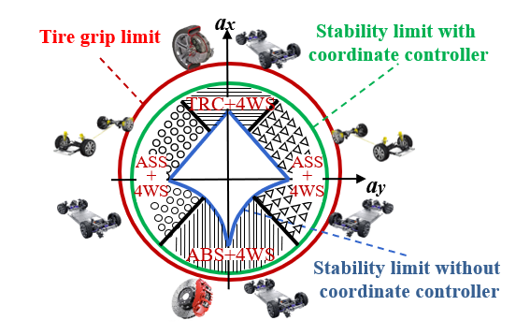

Figure 2: Coordination Control of muti-actuators in Intelligent Chassis

In pursuit of achieving coordinated control of intelligent chassis to prevent conflicts between actuators and enhance performance in extreme conditions, a benchmark problem is put forward for students and researchers who work with vehicle dynamic control in the 8th CVCI, Chongqing 2024. The benchmark issues will be presented in the following section, and the provided simulation testing platform with its technical parameters will be explained in detail. Additionally, evaluation method for benchmarking results will be presented, and the schedule of the benchmark competition can be found on[*http://www.ascl.jlu.edu.cn/vci/cvci2024/Benchmark.htm*](http://www.ascl.jlu.edu.cn/vci/cvci2024/Benchmark.htm).

1. **Benchmark Problem**

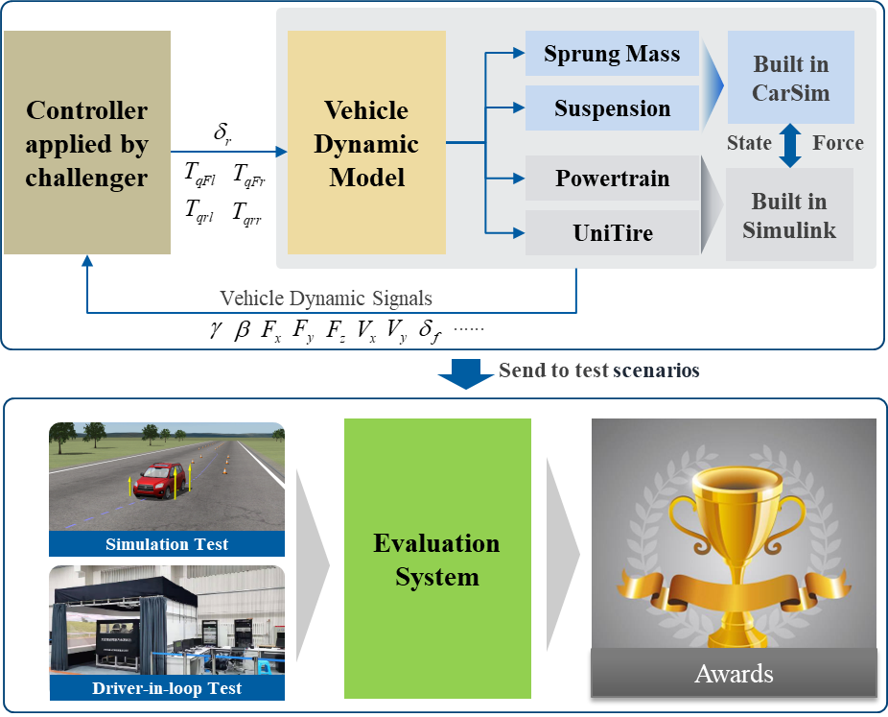

Figure 3: Diagram of the Benchmark Challenge

The benchmark problem in CVCI2024 is to design a controller that coordinates actions of an intelligent chassis with ARS and four distributed in-wheel motors mounted, the framework of benchmark problem is depicted in Figure 3. A high-fidelity vehicle dynamic model is provided by the committee. The main body of the model including sprung mass and suspension system is built in CarSim, which is derived from real testing data, then the tire model employs UniTire built in Simulink, accurately describing the tire characteristics in both pure and combined slip conditions. The powertrain of the vehicle model built in Simulink is composed of four in-wheel motors, which are also the actuators of TVC. It is important to note that the challengers only have control over the steering of the rear wheels. The input for the front wheel steering is obtained from Simulink, the driver model in CarSim, or real drivers on the driving simulator, depending on the specific test scenario. Subsequently an evaluation system derived from some typical standards is employed to measure performance of controllers applied by challengers, according to which the final awards will be determined.

1. **Provided Simulation Platform**

In this section, the simulation platform depicted in Figure 3 will be introduced in detail, including input signals and output signals.

* 1. Model built in CarSim

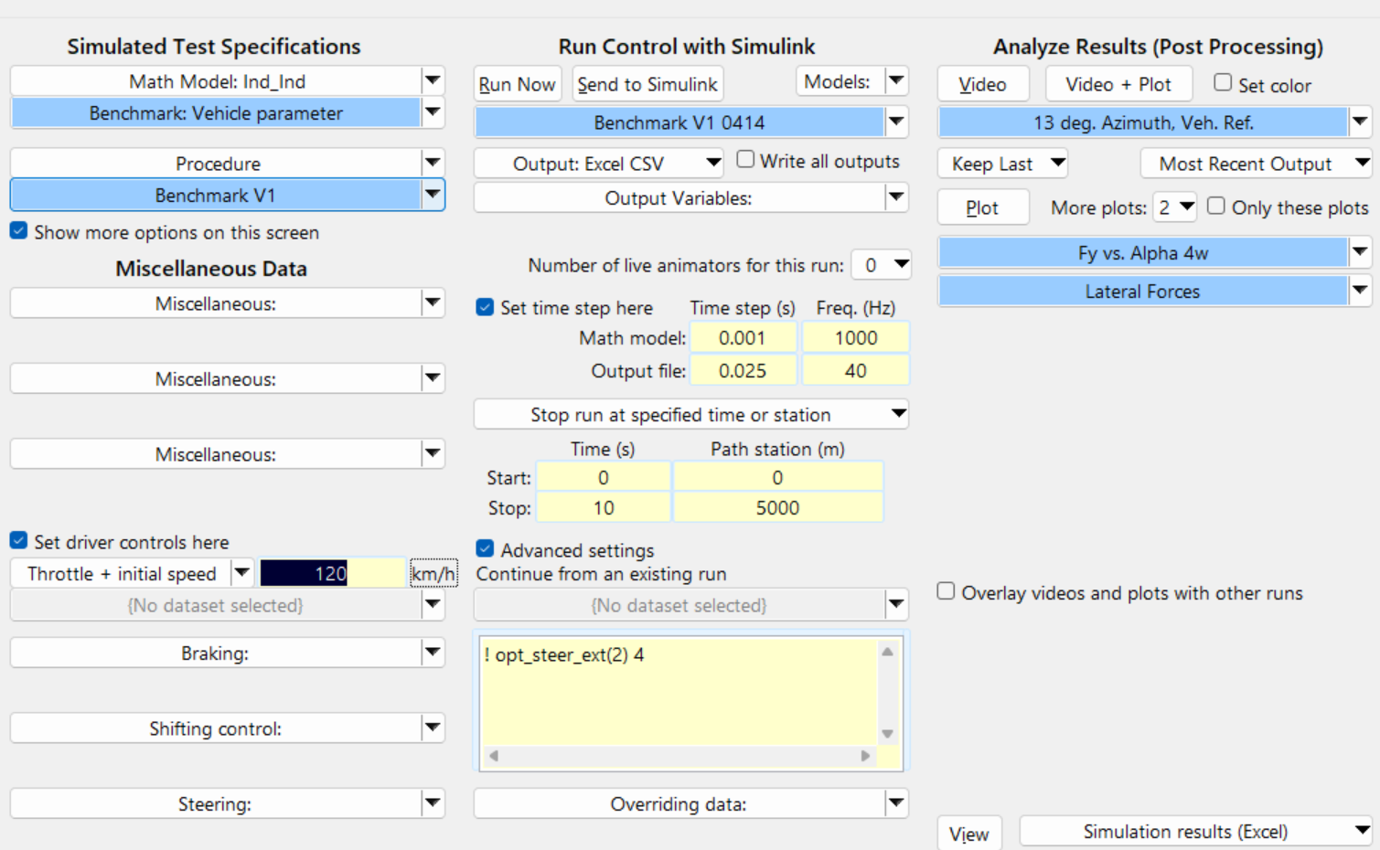

Figure 4: Overview of the CarSim Model

Model built in CarSim is shown in Figure 4, the path to link Simulink should be modified by challengers before co-simulation.

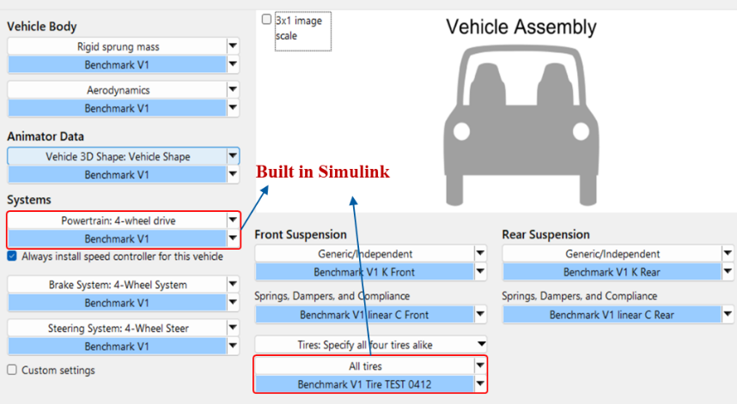

Figure 5: Main body of vehicle model in CarSim

Vehicle body, brake system, steering system and suspension system are modeled in CarSim and the parameters inside are derived from measured data which are not allowed to be modified by challengers. The powertrain model and tire model are built in Simulink which will be introduced later.

Testing ground of objective test is built in CarSim as depicted in Figure 6, the road shape and friction coefficient will be changed with specified test scenarios in evaluation stage. Note that the coordination controller applied by challenger should be adjusted to different tests and the final scores will be a comprehensive consideration of objective tests and subjective tests.

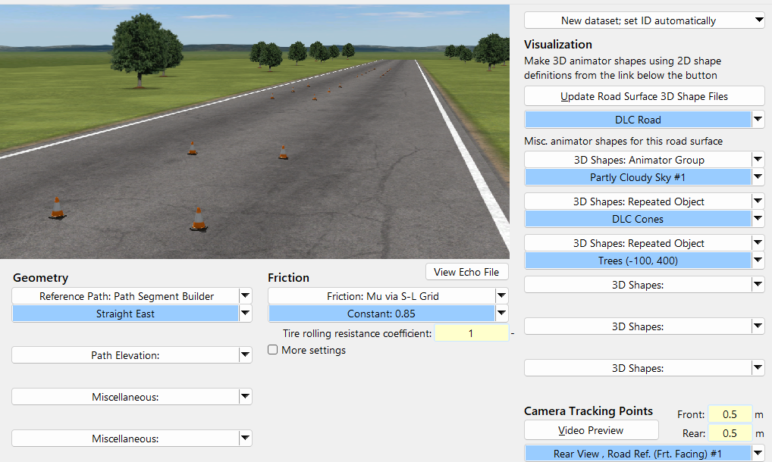

Figure 6: Testing ground in CarSim

* 1. Model built in Simulink

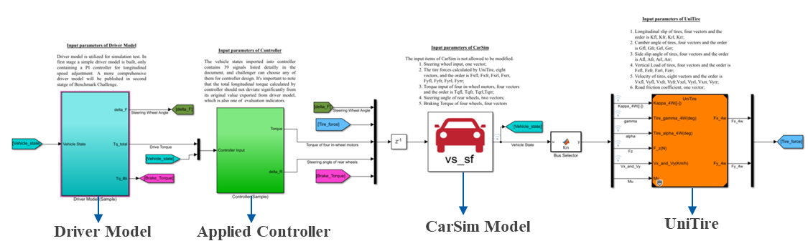

Figure 7: Overview of the Model in Simulink

There are four main modules in Simulink file, i.e., the driver model, the controller developed by challengers, CarSim model sent to Simulink and the UniTire model, as depicted in Figure 7.

The initial driver model, published in the first stage as shown in Figure 8, encompasses solely a PI controller responsible for adjusting the longitudinal speed. This controller generates a total longitudinal torque command, and the steering wheel input.

Remarks:

* The torque command is sent to controller applied by challengers for final torque allocation.
* The total longitudinal driving torque adjusted by challenger’s controller should not deviate significantly from its original value.
* In driver model, challenger can adjust the front steering and target speed for testing their controller.

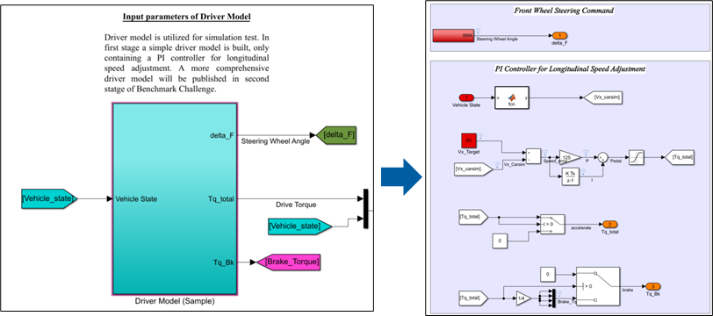

Figure 8: Diver Model

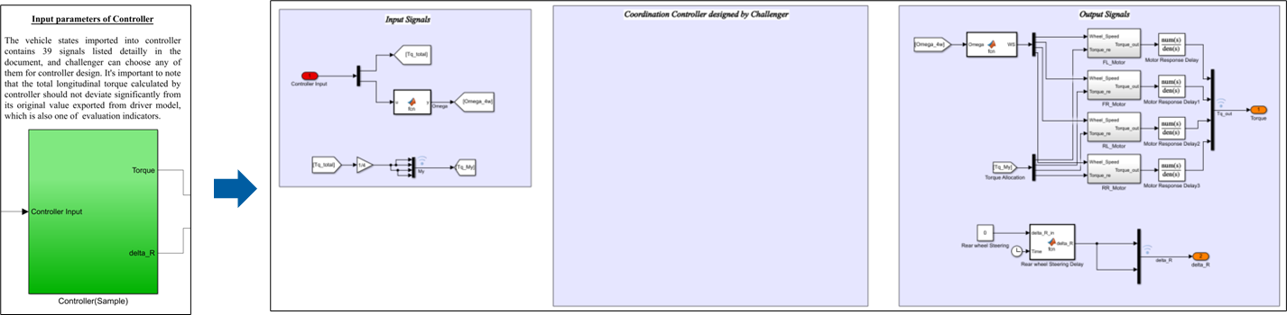

Figure 9: Controller Module

In controller module, as depicted in Figure 9, the torque demands of four in-wheel motors calculated by challenger’s algorithm need to be sent to the motor power limit module, after which the practical torque signals will be exported to the vehicle model. Besides, the signal of rear wheel teering angle is handled before sent into vehicle model, according to the actuator limit. Vehicle states imported into challenger’s controller are listed in Table 1, and challenger can check the CarSim model for more detail description. It is important to note that the controller utilized by the challenger should possess strong generality, enabling it to be easily transplanted to the evaluation team's PC.

There are a total of five sets of signals sent to CarSim, consisting of 19 signals. These include the steering wheel input, torque input of the four in-wheel motors, braking torques for braking system in CarSim, steering angle of the rear wheels, and the tire forces calculated by UniTire. Additionally, there are six sets of signals sent to UniTire model in Simulink, totaling 25 signals. These include the side slip angle, camber angle, longitudinal slip, vertical load, velocity of the tires, and road friction coefficient.

**Table. 1 Vehicle State available for Controller Design**

|  |  |
| --- | --- |
| Parameter | Symbol |
| Longitudinal Slip | Kappa [-] |
| Inclination Tire Angle | Gamma [deg] |
| Tire Side Slip Angle | Alpha [deg] |
| Tire Vertical Load | Fz [N] |
| Tire Longitudinal Velocity | VxCen [km/h] |
| Tire Lateral Velocity | VyCen [km/h] |
| Wheel Rate | AVy [rpm] |
| Vehicle Longitudinal Velocity | Vx [km/h] |
| Vehicle Lateral Velocity | Vy [km/h] |
| Vehicle Longitudinal Acceleration | Ax [g] |
| Vehicle Lateral Acceleration | Ay [g] |
| Front Wheel Steering | Steer_L1 [deg] |
| Rear Wheel Steering | Steer_L2 [deg] |
| X Coordinate of CoG | Xo [m] |
| Y Coordinate of CoG | Yo [m] |
| Side Slip Angle of CoG | Beta [deg] |
| Yaw Rate | AVz [deg/s] |
| Road Friction Coefficient | MuX_L1 [-] |

The UniTire model utilized in Benchmark Challenge is a semi-empirical tire model utilizing a nondimensional form to accurately express tire characteristics under combined camber, cornering and braking/driving conditions with anisotropic tire stiffness and large camber. In Figure 10, the results of UniTire model are validated against the measured data, which show satisfactory accuracy in different conditions.

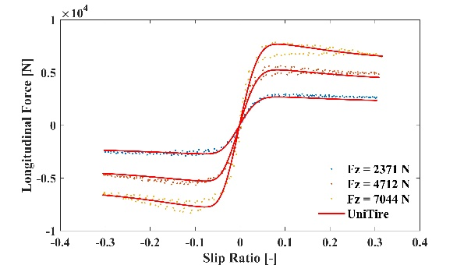

Figure 10: Validation of UniTire Model

1. **Challenging and Evaluating**
   1. Challenging

The task for challengers is to design a controller that coordinates actions of ARS and four distributed in-wheel motors in various driving condition, maximizing the performance of the intelligent chassis in extreme condition. Achieving this objective requires a comprehensive understanding of the coupling mechanisms in vehicle dynamics across the lateral, longitudinal, and vertical directions. Besides control objectives of controller to balance stability and handling performance should be flexible when encountering different driving condition.

* 1. Evaluating

The submitted controller should be delivered to us in a single package and the file format should be “.zip” or “.rar”. Following items should be satisfied in the applied package:

* The version of MATLAB for controller development must be 2020b.
* The version of CarSim for controller development must be 2019.1.
* The main file of the designed controller must be as a module named FirstAuthorName _Controller and saved as FirstAuthor _Controller.slx.
* The necessary pre-computations parameters for controller should be saved in the FirstAuthor_Initial parameters.m.
* The success of submission is only certified based on a letter in reply from us.

The controller submitted to the Benchmark committee will undergo evaluation based on its performance across various experimental parameters. The Simulink-CarSim collaborative simulation provides the simulation environment for simulation tests and a driving simulator provides the environment for driver-in-loop tests. The championship evaluating process will be conducted through the following items.

* + 1. Simulation Test -Step Input Test

The test condition of step input is an objective evaluation referring to GB/T 6323-2014, and will be carried out in co-simulation environment.

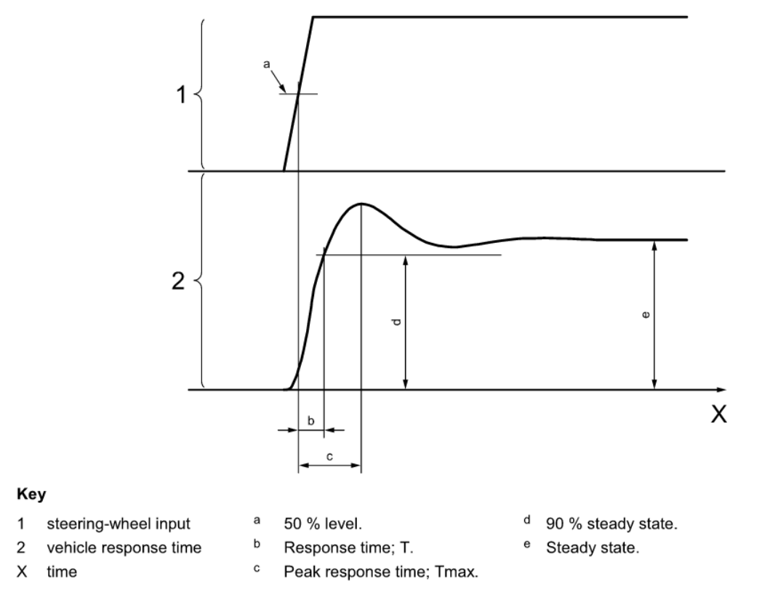

Figure 11: Step steering input

Remarks:

* The steering-wheel angle amplitude is determined by steady-state driving on a circle the radius of which gives the preselected steady-state lateral acceleration of 2 ${m/s}^{2}$, 2.5 ${m/s}^{2}$, and 3 ${m/s}^{2}$ at the required test speed of 100km/h.
* The friction coefficient of testing ground is set as 0.85.

**Table. 2 Experimental Data Record Table for Step Input**

|  |  |  |
| --- | --- | --- |
| Parameter | Symbol | Average |
| Steady-state yaw rate response gain [s-1] |  |  |
| Yaw rate response time [s] |  |  |
| Yaw rate peak response time [s] |  |  |
| Lateral acceleration response time [s] |  |  |
| Lateral acceleration peak response time [s] |  |  |
| Overshoot value of yaw rate [-] |  |  |
| Overshoot value of Lateral acceleration [-] |  |  |

* + 1. Simulation Test-Sinusoidal Input

The test condition of sinusoidal input is an objective evaluation referring to ISO 7401-2011, and will be carried out in co-simulation environment.

Remarks:

* The steering-wheel angle amplitude is determined by steady-state driving on a circle the radius of which gives the preselected steady-state lateral acceleration of 4 ${m/s}^{2}$ at the required test speed of 100km/h.
* The test applying one period of sinusoidal input covers a frequency range of 0.2 Hz to 2 Hz, with 0.6 Hz increased in each test cycle.
* The friction coefficient of testing ground is set as 0.85.

**Table. 3 Experimental Data Record Table for Sinusoidal Input**

|  |  |  |  |
| --- | --- | --- | --- |
| Parameter | Symbol | Mean value | Standard deviation |
| Time lag between steering-wheel angle and lateral acceleration |  |  |  |
| Peak response time *aY* 1 [ms] |  |  |  |
| Peak response time *aY* 2 [ms] |  |  |  |
| Time lag between steering-wheel angle and yaw rate |  |  |  |
| Peak response time $\dot{ψ}$ 1 [ms] |  |  |  |
| Peak response time $\dot{ψ}$ 2 [ms] |  |  |  |
| Lateral acceleration gain [m/s2]/° |  |  |  |
| Yaw velocity gain [s-1] |  |  |  |

* + 1. Simulation Test-Steady state Circular driving

The test condition of steady state circular driving is an objective evaluation referring to GB/T 6323-2014, and will be carried out in co-simulation environment.

**Table. 4 Steady-State Turning Test Evaluation Table**

|  |  |
| --- | --- |
| Road Type | Average Maximum Lateral Acceleration |
| High Grip Surface（$μ=$ 0.8） |  |
| Medium Grip Surface（$μ=$ 0.5） |  |
| Low Grip Surface（$μ=$ 0.2） |  |

Remarks:

* The circular radius is set to 50 meters.
* The vehicle shall accelerate slowly and uniformly with a longitudinal acceleration not exceeding 0.25 ${m/s}^{2}$, until the lateral acceleration of the vehicle reaches 6.5 ${m/s}^{2}$ or the vehicle becomes unstable, while simultaneously recording the dynamic data.
* The experiment shall be conducted three times.
* The final evaluation criterion is the maximum lateral acceleration.
  + 1. Simulation Test-Braking in A Turn

The test condition of braking in a turn is an objective evaluation referring to ISO 7975:1985, and will be carried out in co-simulation environment.

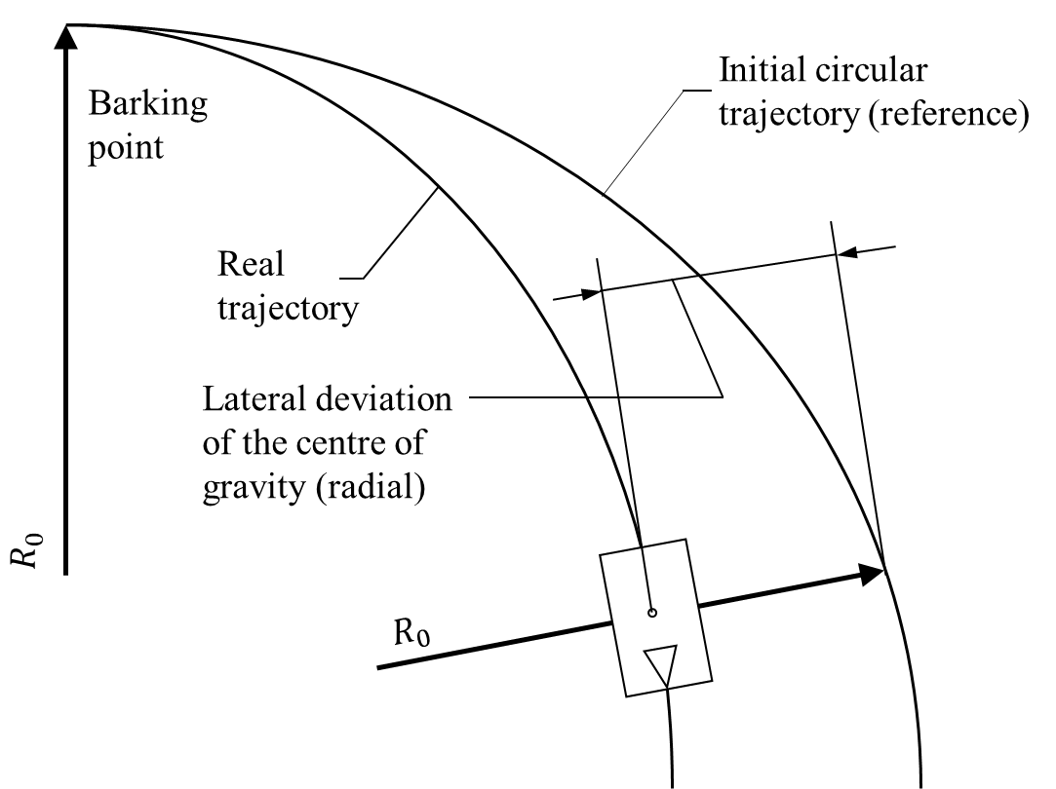

**Figure. 12 Reference and Actual Trajectory**

**Table. 5 Test Conditions Standards**

|  |  |  |
| --- | --- | --- |
| Radius [m] | Lateral acceleration [m/s2] | Corresponding forward velocity [km/h] |
| 30 to 50 | 5±10%  4±10% | (44 to 57)±5%  72±5% |
| 100 |

**Table. 6 Braking in A Turn Test Evaluation Table**

|  |  |  |  |  |  |
| --- | --- | --- | --- | --- | --- |
|  | Slip Angle | Yaw Rate | Steering Sensitivity | Maximum Braking Deceleration | Braking Distance |
| High Grip Surface（$μ=$ 0.8） |  |  |  |  |  |
| Medium Grip Surface（$μ=$ 0.5） |  |  |  |  |  |
| Low Grip Surface（$μ=$ 0.2） |  |  |  |  |  |

Remarks:

* Vehicle speed, circular radius, and the lateral acceleration should be maintained according to the standard.
* The difference of lateral acceleration and forward velocity during 0.3 to 0.8 s and 0.8 to 1.3 s before brake application shall not exceed the mean value by more than 5 % for the lateral acceleration and not more than 3 % for the forward velocity.
* Within 0.4 seconds, the brake pedal stroke from a certain position should be kept as constant as possible. The minimum braking deceleration should be maintained at 2 ${m/s}^{2}$ for at least three seconds. Increase gradually by no more than 1 ${m/s}^{2}$ each time until wheel lock occurs.
  + 1. Simulation Test-Accelerating in A Turn

The test condition of accelerating in a turn is an objective evaluation modified from ISO 7975:1985, and will be carried out in co-simulation environment.

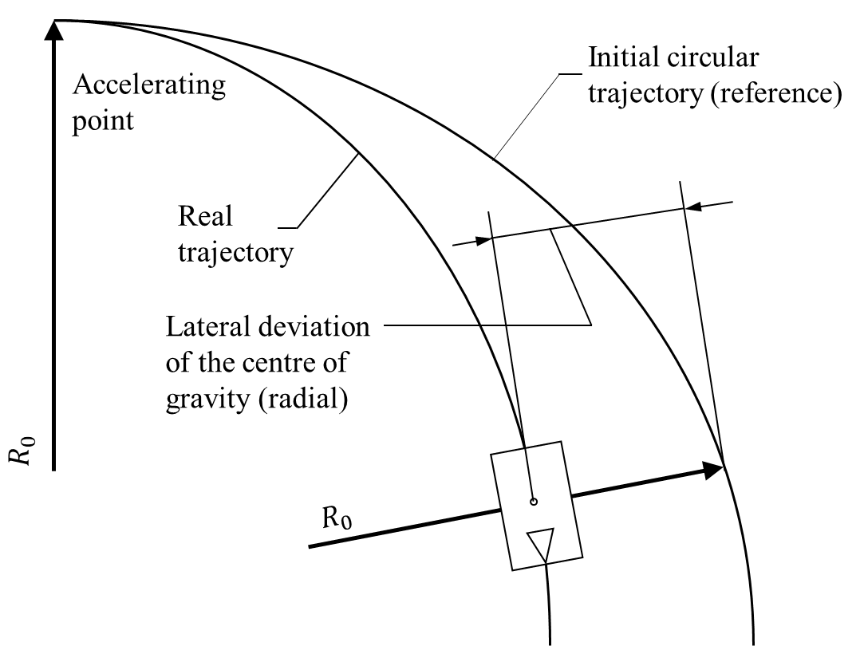

**Figure. 13 Reference and Actual Trajectory**

**Table. 7 Accelerating in A Turn Test Evaluation Table**

|  |  |  |  |  |
| --- | --- | --- | --- | --- |
| Road Type | Maximum Speed | Slip Angle | Yaw Rate | Maximum Acceleration |
| High Grip Surface（$μ=$ 0.8） |  |  |  |  |
| Medium Grip Surface（$μ=$ 0.5） |  |  |  |  |
| Low Grip Surface（$μ=$ 0.2） |  |  |  |  |

Remarks:

* The vehicle maintains a speed of 45 kph while navigating a circular path with a radius of 50 meters.
* Within 0.4 seconds, the throttle pedal stroke from a certain position should be kept as constant as possible. The longitudinal acceleration should be maintained at 2 ${m/s}^{2}$, increasing gradually by no more than 1 ${ m/s}^{2}$ each time until vehicle slip occurs.
  + 1. Simulation Test-Sine with Dwell Test

The test condition of sine with dwell is an objective evaluation referring to GB/T 30677-2014, and will be carried out in co-simulation environment.

Remarks:

* The vehicle maintains a stable speed of 80 km/h. Steering wheel is turned in one direction at an angular velocity of 13.5deg/s until the vehicle reaches a lateral acceleration of 5 ${m/s}^{2}$. The baseline reference for the steering wheel angle value is determined when the lateral acceleration reaches 3 ${m/s}^{2}$, denoted as A.
* The vehicle maintains a stable speed of 80 km/h. Starting with a steering wheel angle value of 1A, a sine wave input is applied to the steering wheel at a frequency of 0.7 Hz, completing one cycle. The steering wheel remains at the position of the second peak for 500 milliseconds.
* Similarly, tests are conducted with steering wheel angle values of 2A to 5A, increasing the steering wheel angle by A for each test cycle.

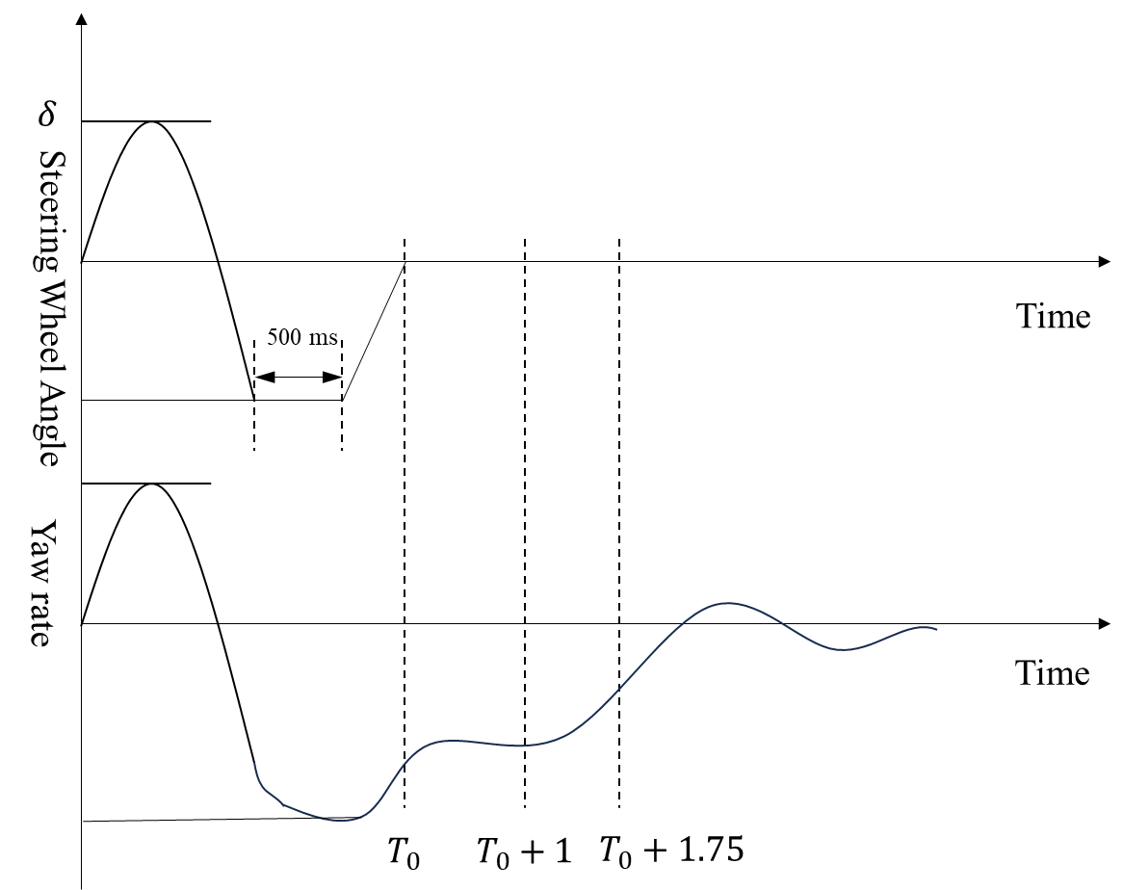

**Figure. 14 Sine with Dwell Test**

**Table. 8 Sine with Dwell Test Evaluation Table**

|  |  |  |
| --- | --- | --- |
| Steering Wheel Angle | Lateral Displacement | Vehicle Stability |
| A |  |  |
| 2A |  |  |
| 3A |  |  |
| 4A |  |  |
| 5A |  |  |

* + 1. Simulation Test-Trapezoidal Amplification Test

Trapezoidal amplification test is originally used in audio distortion testing and now is introduced for vehicle dynamic test in the Benchmark. This test is a method used to evaluate the response characteristics of a system, typically involving the application of a trapezoidal input signal to assess how the system amplifies or attenuates the input signal. It helps in understanding the system's amplification or attenuation properties, transient response, and frequency response, as depicted in Figure 13.

**Table. 9 Experimental Data Record Table for Trapezoidal Amplification Test**

|  |  |  |
| --- | --- | --- |
| Parameter | Symbol | Average |
| Steady-state yaw rate response gain [s-1] |  |  |
| Yaw rate response time [s] |  |  |
| Yaw rate peak response time [s] |  |  |
| Lateral acceleration response time [s] |  |  |
| Lateral acceleration peak response time [s] |  |  |
| Overshoot value of yaw rate [-] |  |  |
| Overshoot value of Lateral acceleration [-] |  |  |

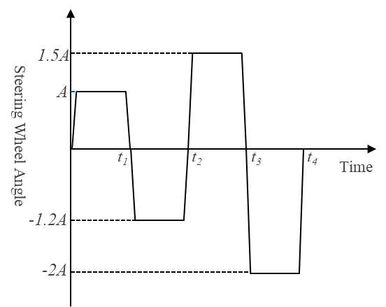

**Figure. 15 Trapezoidal Amplification Test**

* + 1. Simulation Test-J-Turn Test

The test condition of J-Turn is an objective evaluation referring to NHTSA, and will be carried out in co-simulation environment.

Remarks:

* During the test, the vehicle speed should be maintained within the range of 56-96 km/h, and the driver should maintain the vehicle speed as steady as possible.
* After the vehicle travels along a straight line for a certain distance and accelerates to the target test speed, the driver turns the steering wheel approximately 330 degrees to the left or right at a rate of 1000 deg/s. During the test, data such as vehicle speed, yaw rate, vehicle roll angle and lateral acceleration should be recorded.
* J-turn tests should be conducted three times.

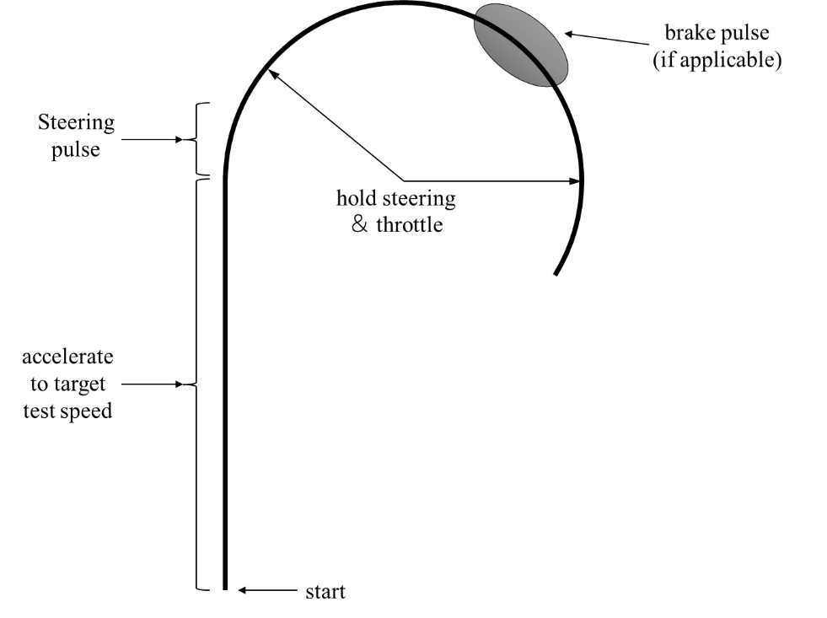

**Figure. 16 Driving trajectory of J-Turn test**

**Table.10 J-Turn Test Evaluation Table**

|  |  |  |  |  |
| --- | --- | --- | --- | --- |
| Road Type | Maximum Speed | Yaw Rate | Slip Angle | Vehicle Stability |
| High Grip Surface（$μ=$ 0.8） |  |  |  |  |
| Medium Grip Surface（$μ=$ 0.5） |  |  |  |  |
| Low Grip Surface（0.2） |  |  |  |  |

* + 1. Simulation Test-Fishhook Maneuver Test

The test condition of fishhook maneuver is an objective evaluation referring to NHTSA, and will be carried out in co-simulation environment.

Remarks:

* During the test, the vehicle speed should be maintained within the range of 56-80 km/h, and the driver should maintain the vehicle speed as steady as possible.
* When the vehicle reaches the target speed, the driver turns the steering wheel to the left or right for approximately 270 degrees at the rate of 720deg/s, and then turns the steering wheel in the opposite direction for 540 degrees at the same rate within one second. During the test, the vehicle data should be recorded.
* Fishhook tests should be conducted three times.

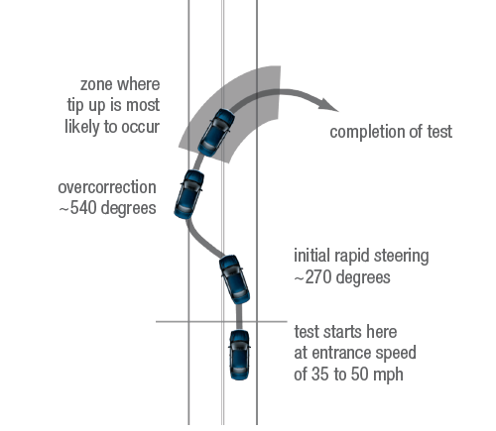

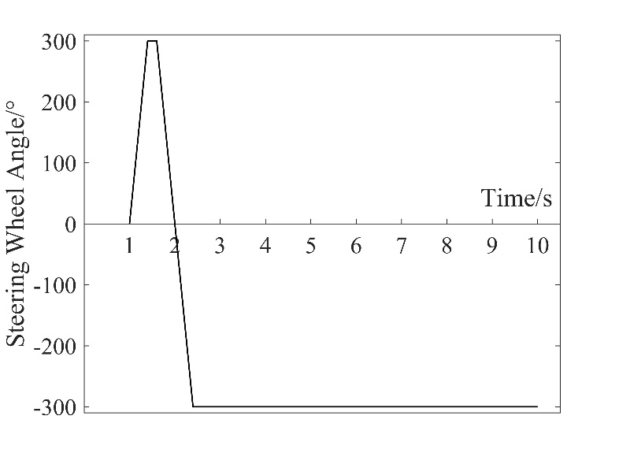

**Figure. 17 Driving trajectory of Fishhook test**

**Table. 11 Fishhook Test Evaluation Table**

|  |  |  |  |  |
| --- | --- | --- | --- | --- |
|  | Maximum Speed | Yaw Rate | Slip Angle | Vehicle Stability |
| High Grip Surface（$μ=$ 0.8） |  |  |  |  |
| Medium Grip Surface（$μ=$ 0.5） |  |  |  |  |
| Low Grip Surface（0.2） |  |  |  |  |

* + 1. Driver-in-loop Test -Double Lane Change

The test condition of double lane change is a driver-in-loop evaluation referring to ISO 3888-1-2002, and will be carried out in co-simulation environment.

Remarks:

* The simulation of double lane change is carried out according to ISO standard, and the highest speed (constant longitudinal speed) passing through the track within the lane boundary will be taken as effective passing speed for evaluation.
* Besides combined condition of lateral-longitudinal coupling will be tested with accelerating and braking the vehicle in DLC.
* The center line is used as the reference track in the double lane change test, which is also used to calculate the trajectory tracking error.
* The final score of this test is mainly determined by the highest passing speed. When difference of highest passing speed between algorithms is less than 5km/h, the trajectory tracking error will be added as scoring reference.

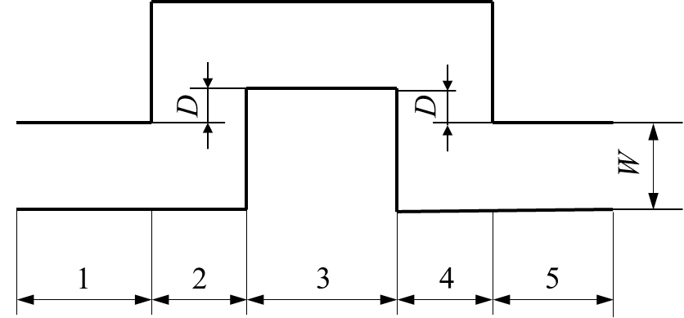

**Figure. 18 Test Path of DLC**

**Table.12 Double Lane Change Test Algorithm Score Table**

|  |  |  |
| --- | --- | --- |
|  | Maximum Passing Speed | Track Tracking Error |
| High Grip Surface（$μ=$ 0.8） |  |  |
| Medium Grip Surface（$μ=$ 0.5） |  |  |
| Low Grip Surface（0.2） |  |  |

* + 1. Driver-in-loop Test-Slalom Test

The test condition of slalom test is a driver-in-loop evaluation referring to GB/T 6323-2014, and will be carried out on driving simulator.

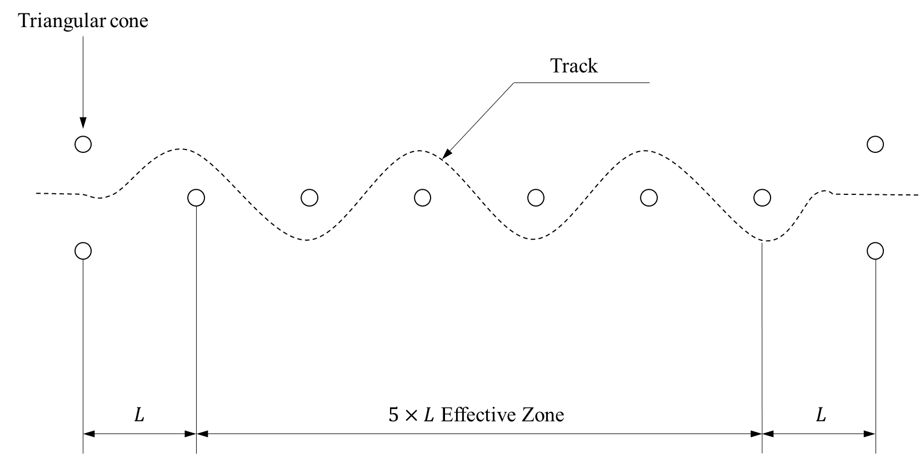

**Figure. 19 Driving trajectory of the Slalom test**

Remarks:

* The slalom test is carried out by a group of drivers according to GB/T 6323-2014, and the highest passing speed without colliding the triangular cone will be taken as the effective passing speed.
* The final score for this test is a weighted value of the highest passing speed and the average value of vehicle states.

**Table.13 Slalom Test Evaluation Table**

|  |  |  |  |  |  |  |
| --- | --- | --- | --- | --- | --- | --- |
| Road Type | maximum allowable speed | average steering wheel angle | average yaw rate | average lateral acceleration | roll angle of average speed | tire slip ratio |
| High Grip Surface（$μ=$ 0.8） |  |  |  |  |  |  |
| Medium Grip Surface（$μ=$ 0.5） |  |  |  |  |  |  |
| Low Grip Surface（0.2） |  |  |  |  |  |  |

* + 1. Driver-in-loop Test-Free Driving Test on Dynamic Square

The free driving test on a square belongs to subjective evaluation test, and it adopts the form of driver-in-loop test on driving simulator.

A group of drivers will manipulate the vehicle freely on the simulator to test the robustness and adaptability of the controllers applied by challengers. And the subjective rating is referring to the enterprise standards of BMW.

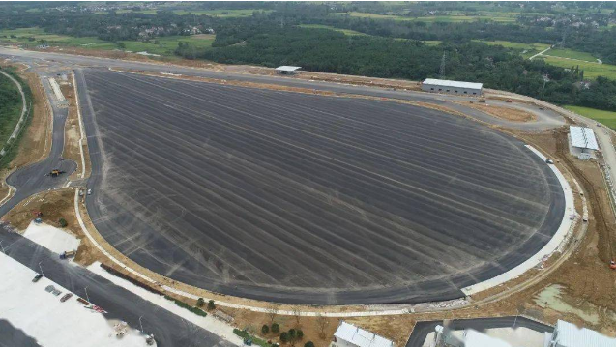

**Figure. 20 Dynamic Square**

**Table. 14 Subjective Test Evaluation Table**

|  |  |
| --- | --- |
| Note | Subjective Rating |
| 10 | Vehicle is outstanding |
| 9 | Vehicle is excellent |
| 8 | Vehicle is very good and meets all expectations |
| 7 | Vehicle is good, minor deviations from the nominal specification |
| 6 | Vehicle is barely satisfactory |
| 5 | Vehicle is unsatisfactory |
| 4 | Vehicle is deficient |
| 3 | Vehicle conditions leads to high customer annoyance |
| 2 | Vehicle causes a breakdown |
| 1 | Vehicle fails to meet safety requirements |

* + 1. Driver-in-loop Test-Road Testing for Vehicle Stability.

The road test for vehicle stability here belongs to subjective evaluation test, and it adopts the form of driver-in-loop test on driving simulator. This supplementary test will be utilized for the competition and made available to challengers during the mid-event stage of the Benchmark. Ultimately, the completion time will be included as a bonus factor in the overall scoring.

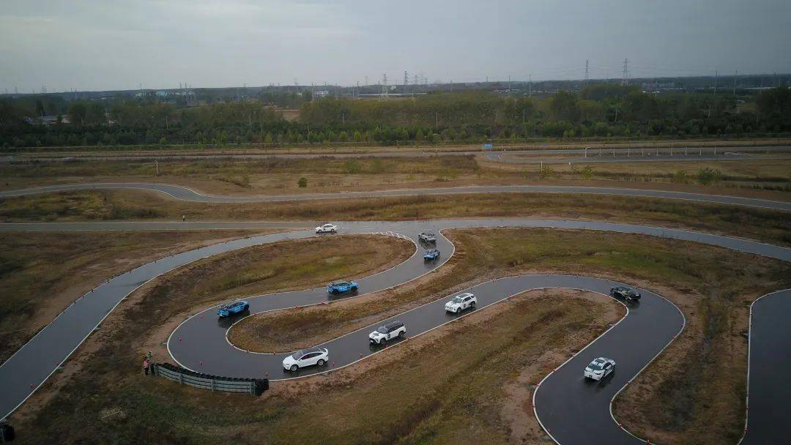

**Figure. 21 Handling stability road test**

Remarks:

* The primary evaluation criterion for this test is the time taken by the vehicle to complete one run of the handling stability road.
* This test condition aims to assess the vehicle's handling stability performance under various intensities of curves and slopes.
* Test can also be conducted on handling stability road under different adhesion coefficient.
  1. Final Scoring

The principle for final scoring will be published in mid-stage of Benchmark Challenge.

1. **Challenge Process**
   1. How to participate
2. Challengers need to download the registration form from the official website, fill it up and send it back to the designated email address for review according to the request on[*http://www.ascl.jlu.edu.cn/vci/cvci2024/Benchmark.htm*](http://www.ascl.jlu.edu.cn/vci/cvci2024/Benchmark.htm).
3. After the review, the organizer will send the model package (model in CarSim, model in Simulink) to challengers.
4. After receiving the model package, challengers need to develop relevant algorithms and programs for the proposed problems. The program code should adapt for the Matlab version specified by the organizer.
5. Challengers should submit the specification of the algorithm they designed before the deadline specified by the official website of CVCI2024, describing in detail the coordination control algorithm used. The specification can be written as a full paper to participate in the submission of the CVCI2024 paper, or it can only be used as a position paper to participate in the challenge.
6. Challengers need to submit the algorithm program due by the deadline specified in the official website. The organizer will run the submitted code on the simulator and evaluate the simulation data. Challengers' solutions are ranked and awarded according to the comprehensive performance according to the submitted programs.
   1. Awards
7. There will be gold, silver, and bronze prize for the challenge, as well as several winning prizes.
8. Challengers need to register and participate in the CVCI2024 conference, and share their control schemes and communicate on the Special Session of the challenge. After the exchange, the organizer will announce the list of winners.